# Step 3 Tracing

In this Step 3 that is the Tracing Stage, I went through all the codes to figure out where the error was. As seen in the previous step that is the Simplification stage, it was found that the error was in the checkout case. Thus, I went through the Use Case of the checkout case and went through every method that run that case.

There were five errors that were found in the code. They are as follows

1. First, I went to the Booking class and checked all the methods. In the checkIn method it was found that the change of state was missing.

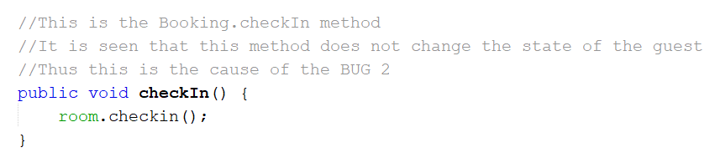

1. Later, I went to the checkout method in the Booking class. Here too the change of state was missing.

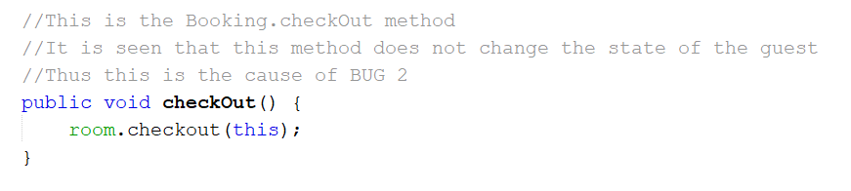

1. Now I had gone to the Hotel class. In this class I saw the checkout method and found out that the booking object was not removed from the activeBookingsByRoomId HashMap.

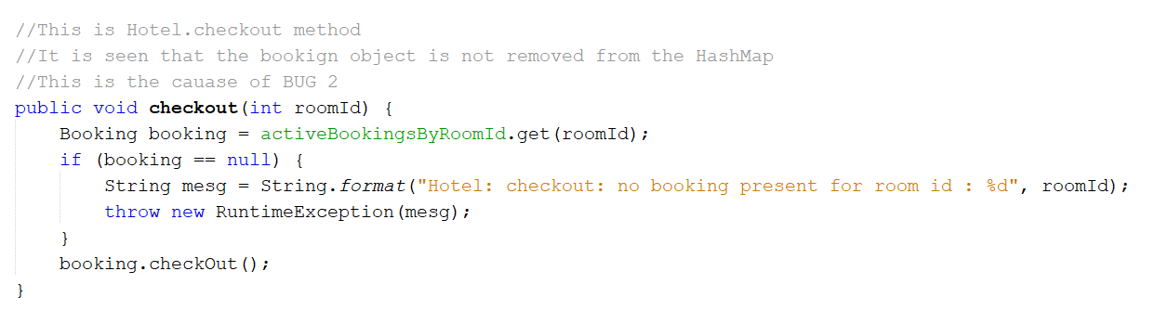

1. Now it was the Room class. It was seen that in the checkout method the object was not removed from the bookings List.

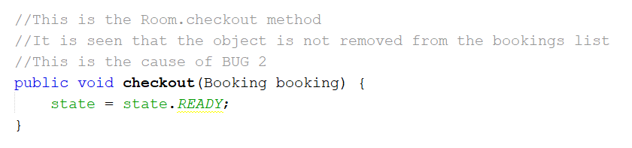

1. For the bug about the not addition of service charges while the checkout case was progressing, I went through all the Service Charge method. Later in the addServiceCharge of the Booking class it was found that the double ‘cosst’ was misspelled by mistake. This is the cause of BUG 1 where it won’t display the proper service charge, because it didn’t add the service charge to the charges list.

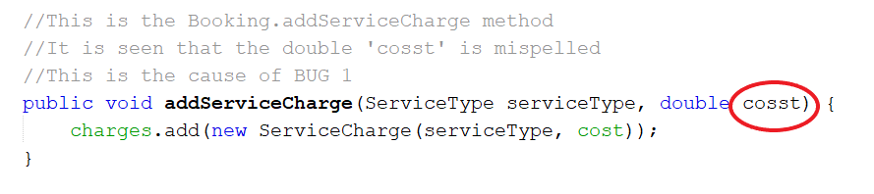

These were the cause of the reported bugs in the program.